**NetBios (Easy)(50 points)**

**We captured some traffic can you figure out what is going on?**

*NetBIOS definition- NetBIOS is an acronym for Network Basic Input/Output System. It provides services related to the session layer of the OSI model allowing applications on separate computers to communicate over a local area network. As strictly an API, NetBIOS is not a networking protocol (but is a type of protocol).

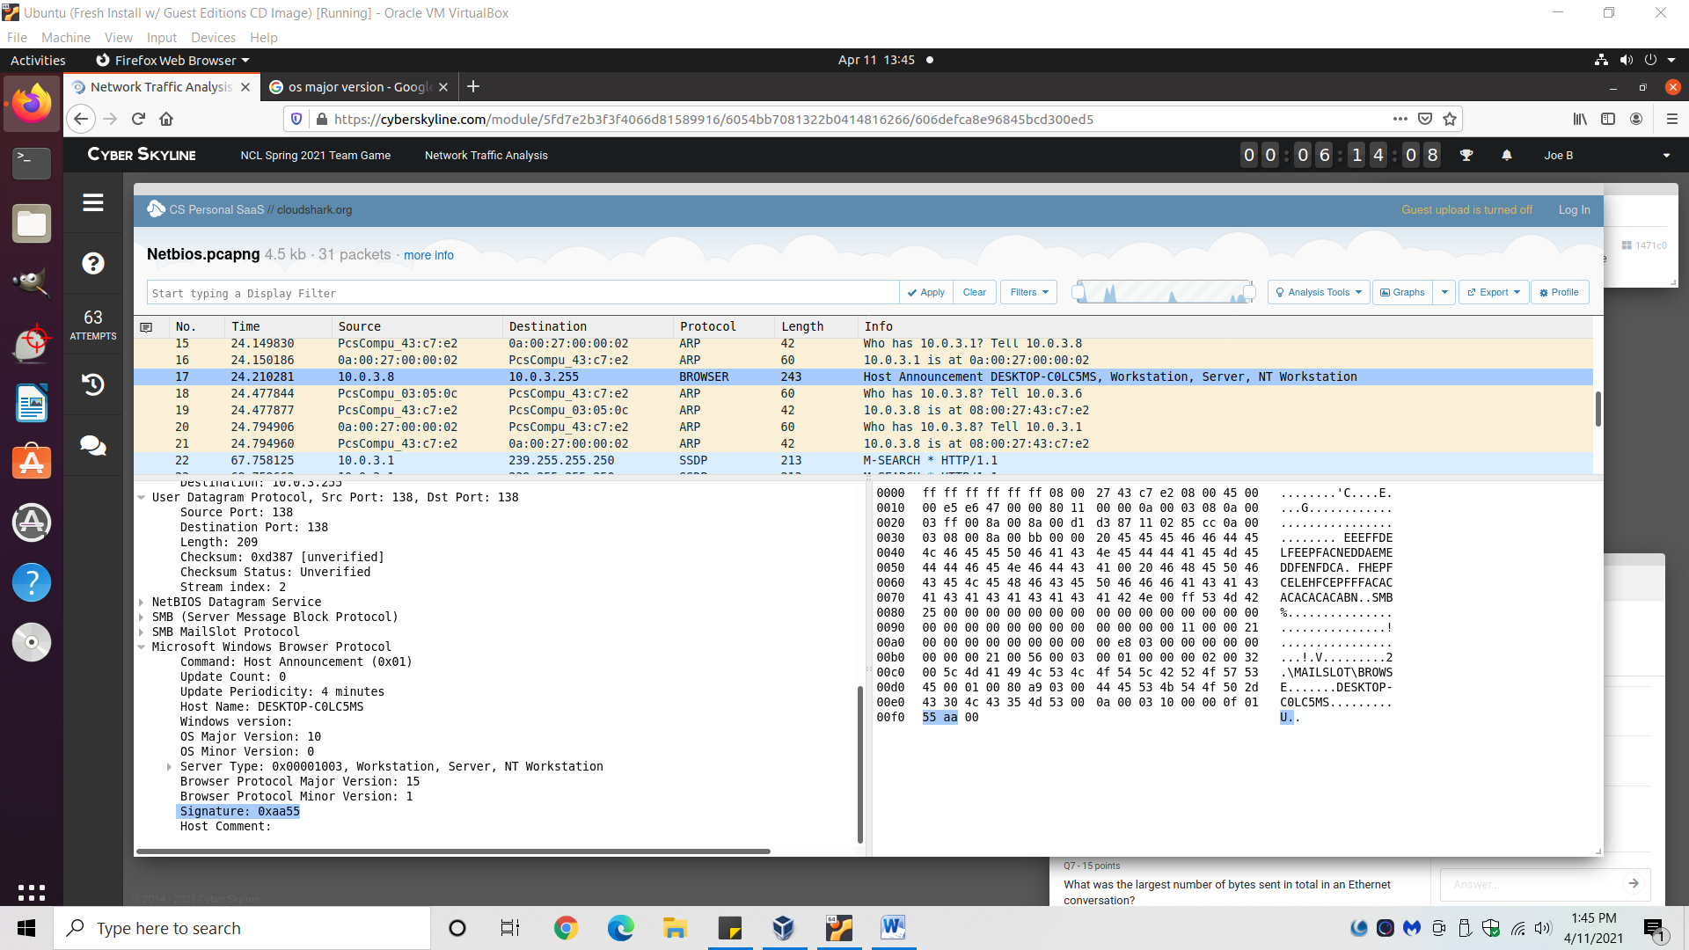

1. Search for packet that says “Host Announcement…” in the info field and click on it.
2. On left-hand side, expand “Microsoft Windows Browser Protocol.”
   1. Can also click around on hex #’s to the right to find answers.
3. All info to the below questions can be found from here.

**What IP sent a host announcement packet?**

Answer: 10.0.3.8

**What was the major version of that computer's operating system?**

Answer: 10

**What was the minor version of that computer's operating system?**

Answer: 0

**What was the signature of the NetBios announcement packet, in hexadecimal representation?**

Answer: 0AA55

**What is 10.0.3.8's netbios name?**

Answer: DESKTOP-C0LC5MS

**What is 10.0.3.6's netbios name?**

1. Click packet where the source is 10.0.3.6.
2. On left-hand side, expand “NetBIOS Name Service.”
3. Expand “Answers.”

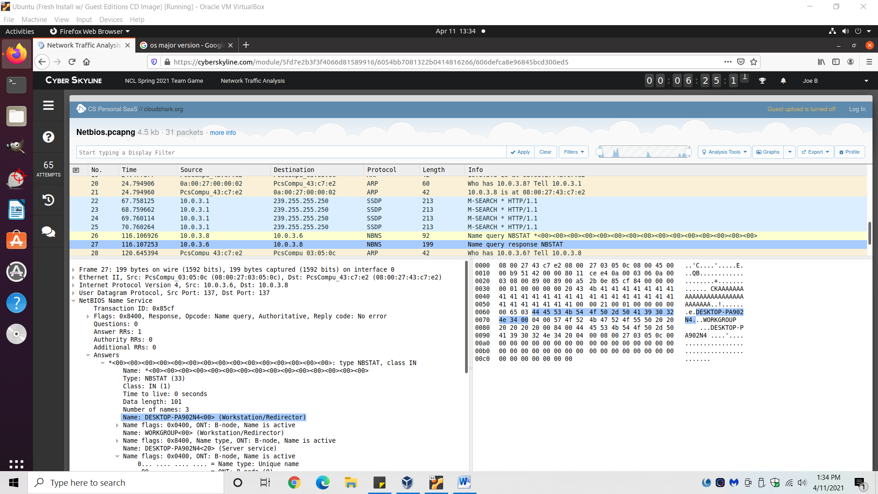

Answer: DESKTOP-PA902N4

**What was the largest number of bytes sent in total in an Ethernet conversation?**

1. Go to “Analysis Tools” near the top right.
2. Click on “Protocol Conversation.”

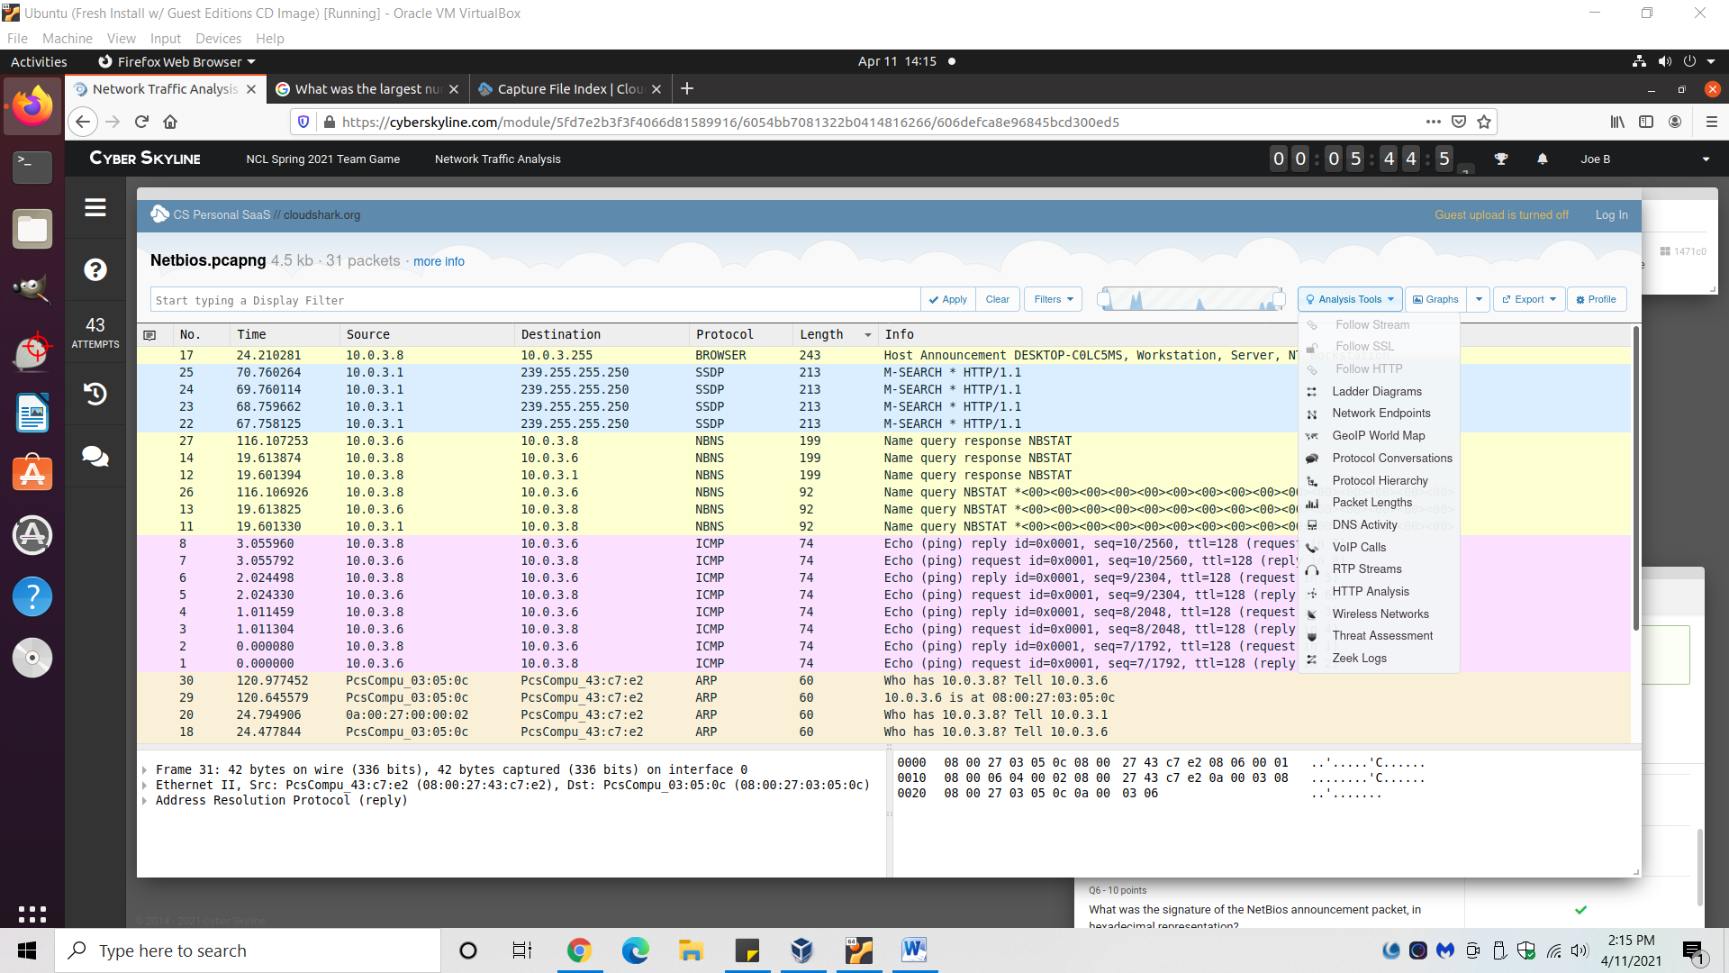

1. Sort by “eth” in the top left.

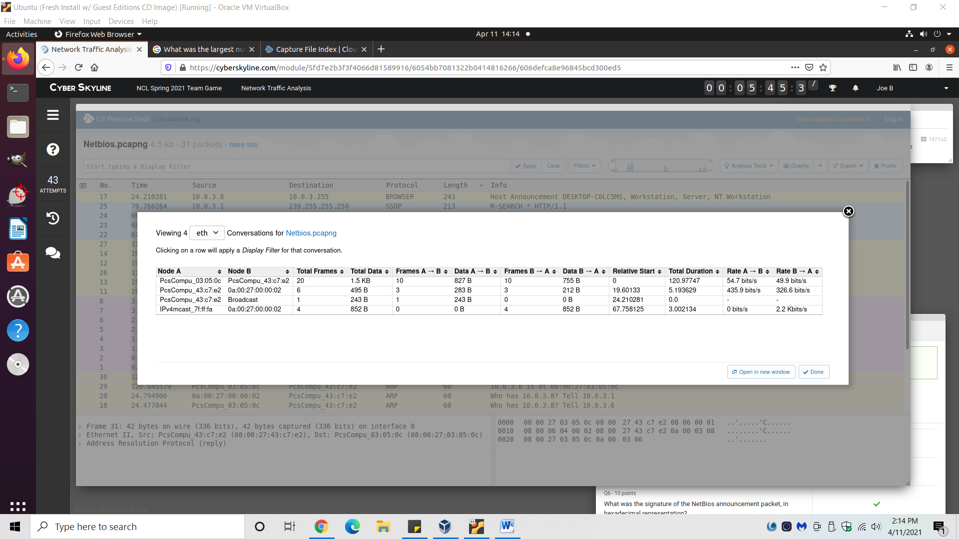

Answer: 1.5KB